flowchart

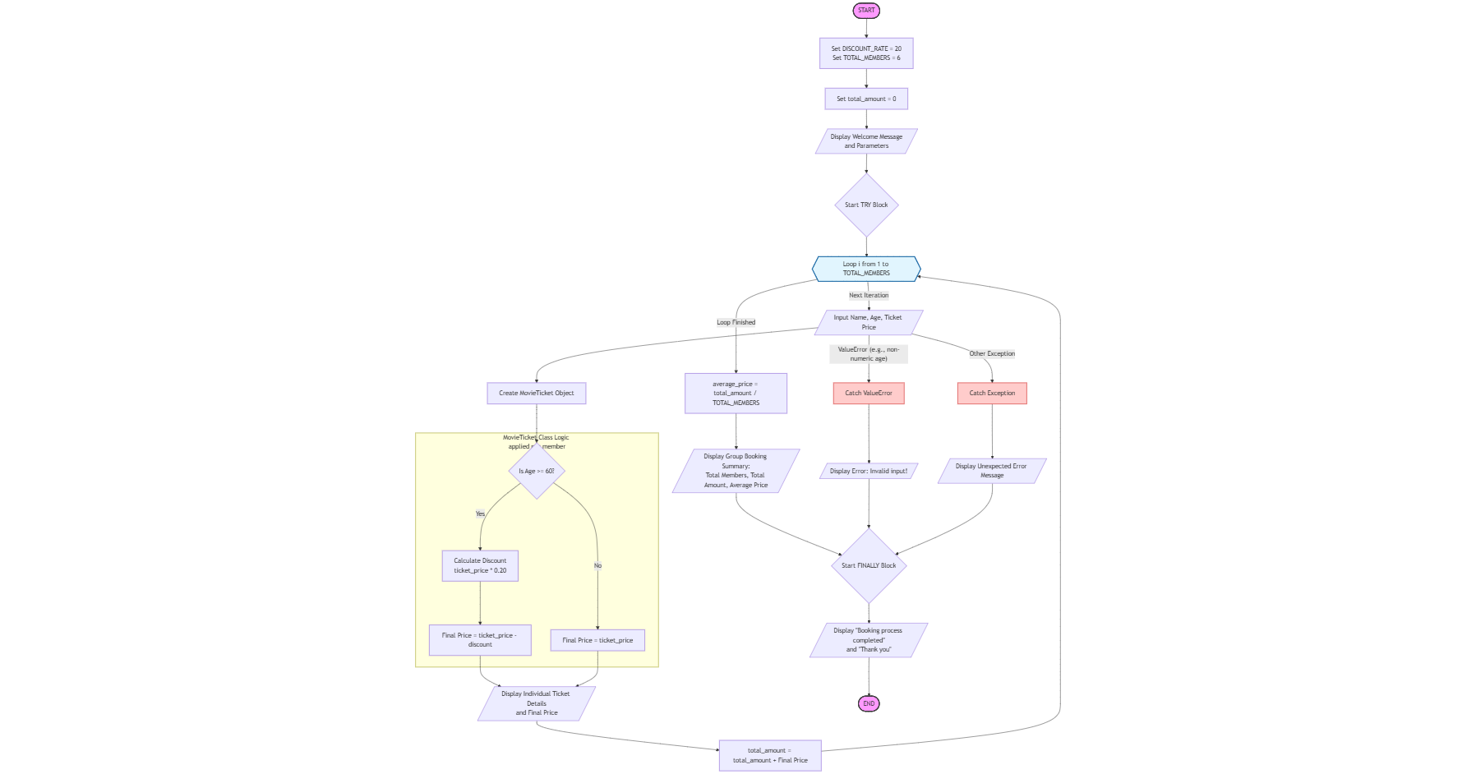

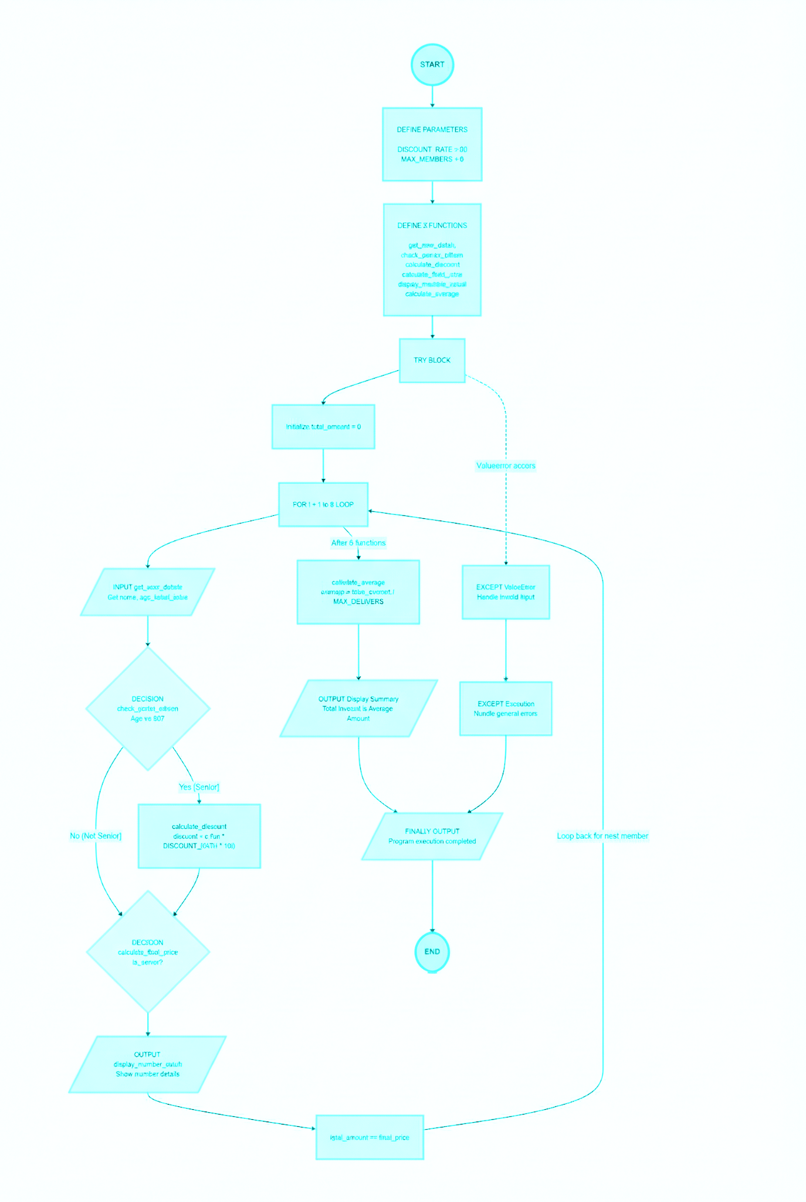

algorithm
Movie Ticket Discount System for Senior Citizens
Overview
This Python program calculates the ticket price for a group of 6 members, offering a 20% discount to senior citizens (age 60+).

Speciality of this program:

Object-Oriented Approach: Uses a MovieTicket class to encapsulate member data and behavior.
Modular Code: Separates concerns into methods like is_senior_citizen, calculate_discount, and display_ticket_details.
Error Handling: Handles invalid inputs (e.g., non-numeric values) using try-except blocks.
Senior Citizen Discount: Offers a specific discount category for senior citizens.

How it Works

1. The program asks for user details (name, age, ticket price) for a group of 6 members.
2. It creates a MovieTicket object for each member and checks if they're a senior citizen (age 60+).
3. If a member is a senior citizen, a 20% discount is applied to their ticket price.
4. The program displays ticket details for each member, including the discount applied and final price.
5. After all members' details are entered, it displays a group booking summary (total members, total amount, average ticket price).

Key Features
Calculates discount for senior citizens (20%).
Displays detailed ticket information for each member.
Shows group booking summary with total amount and average ticket price Handles errors for invalid inputs.

Use Case
MovieTicket is suitable for small movie theaters or event organizers offering discounts to senior citizens for group bookings.

Steps Involved
1. User Input: Get details for 6 members and create MovieTicket objects.
2. Senior Citizen Check: Use is_senior_citizen() to check for discount eligibility.
3. Discount Calculation: Calculate discount using calculate_discount().
4. Display Results: Show ticket details for each member using display_ticket_details().
5. Group Summary: Calculate and display total amount and average price.

DFD
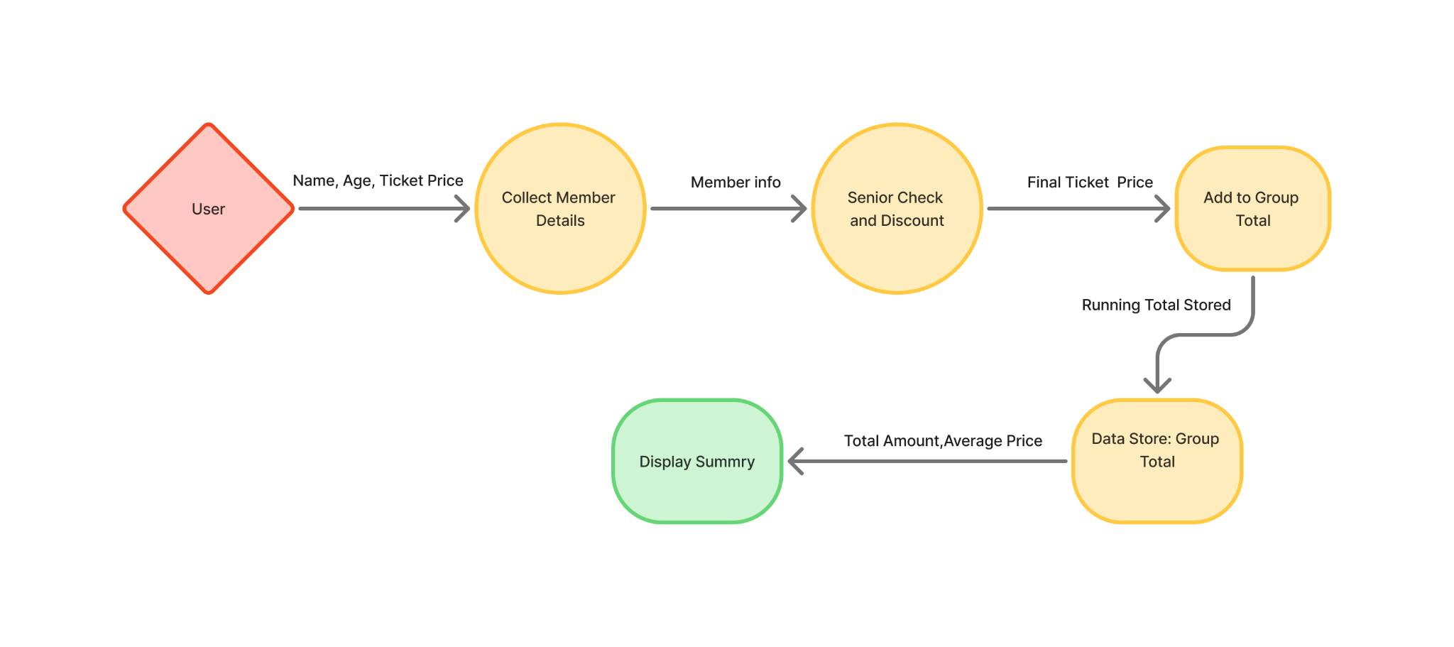
Data Flow Diagram Of Movie Ticket Discount System for Senior Citizens

